2018 Top 10 Business Campaigns

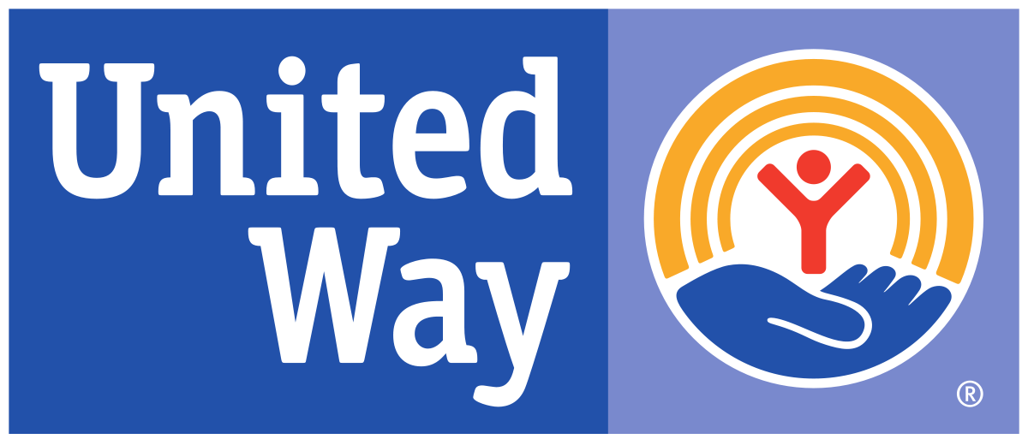

Mary Lanning Healthcare $67,337.00
Dutton-Lainson $45,000.00
Paperworks Packaging $27,094.00
T-L Irrigation Company $25,497.89
Five Points Bank $25,039.60
Eaton Corporation $21,116.39
Hastings Public Schools $20,697.00
City of Hastings $14,819.00
Thermo King – Ingersoll Rand $14,154.28
Pinnacle Bank $9,553.00

